Ideation Phase
Empathize & Discover

Date | 31 January 2025
Team ID
Project Name | E-Commerce
Maximum Marks | 4 Marks

Empathy Map Canvas:
Understand the needs, frustrations, and behaviours of E-Commerce professionals s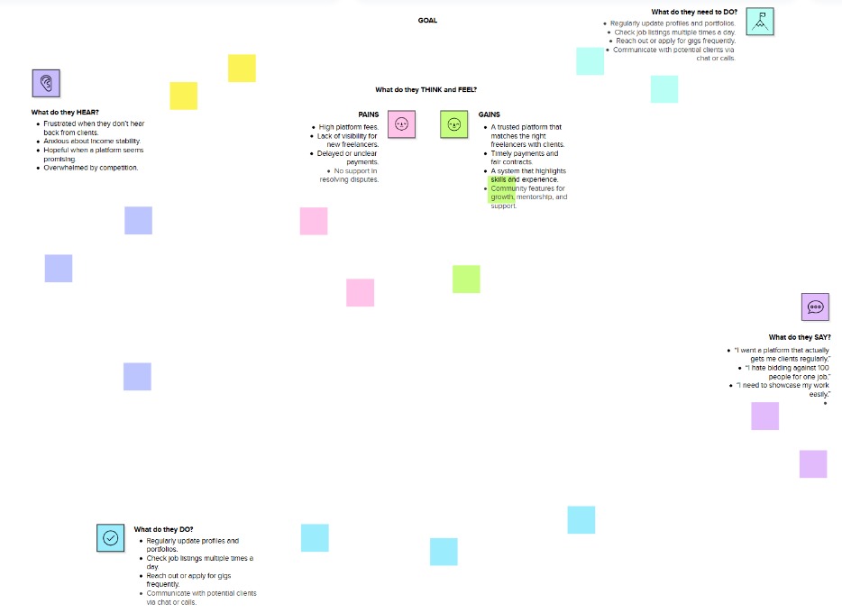seeking consistent work through a platform like Freelance Finder.

Reference: https://www.mural.co/templates/empathy-map-canvas

